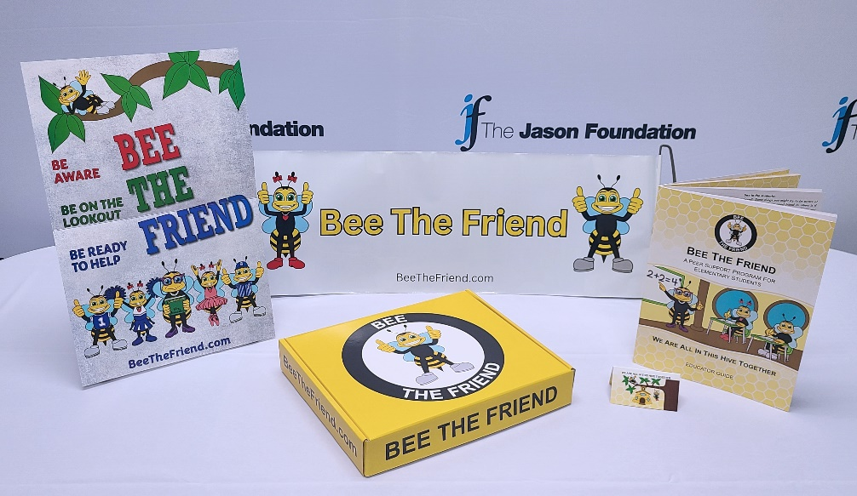

**ABOUT BEE THE FRIEND ELEMENTARY PROGRAM UNIT:**

The Jason Foundation, Inc. (JFI), one of the nation’s leading providers of programs and resources for the awareness and prevention of youth and young adult suicide, has developed a new peer support program for elementary students in grades 3-5, Bee the Friend.

Bee the Friend is a positive, engaging program that fosters friendship and prepares our young children to become compassionate, supportive, and responsible middle and high school students. It aims to guide children in becoming the best friends they can be through acts of kindness, sharing, observing, showing empathy, and supporting their peers. Bee the Friend refrains from using the term suicide, discussing suicide statistics, or addressing risk factors and warning signs. Students will learn how to show the characteristics of a good friend, be mindful of their surroundings and their peers, identify situations in which they can show empathy and be ready to help their peers, identify a student who might need a friend or help from an adult, and identify adults who can assist them. To learn more about Bee the Friend, visit [www.BeeTheFriend.com](http://www.BeeTheFriend.com)

The Bee the Friend kit includes:

* Educator Guide  
* Bee the Friend pull out sign  
* Bee the Friend poster (2)  
* Bee the Friend pledge cards (60)

**HOW TO ORDER THE UNIT:**JFI Representatives may order a sample kit for themselves by contacting their JFI Divisional Director. A sample kit will cost $14.30 plus shipping.

JFI Representatives can market the kits to Elementary Schools (teacher, counselors, etc.) for grades 3-5. A order form must be completed in its entirety and returned to your JFI Divisional Director. The ordered kits will be mailed to the individual from JFI corporate. The cost of the kit and shipping will be billed just as all other JFI materials.